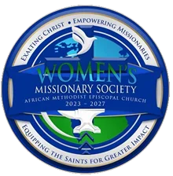
Ninth Episcopal District Women's Missionary Society Skills Bank Survey
Sherryl Whiting, 9th District WMS President
Deana McAllister, Episcopal Supervisor
Bishop Julius H. McAllister Jr., Presiding Prelate

Demographics:

Name: _________________________________________________________

Email Address: __________________________________________________

Address with city and state:_________________________________________

_________________________________________

Contact Number: ________________________________________________

Local Church: ___________________________________________________
Pastor's Name: __________________________________________________
Missionary President: _____________________________________________
Years of Membership: _____________________________________________
Which Conference do you belong to? _________________________________

Current Skills Assessment
For each skill area, rate your proficiency (Novice, Intermediate, Advanced, Expert) by placing an X in the appropriate box

Skill/Ranking | Novice  Beginner | Intermediate | Advance | Expert
Leadership & Planning
Event Coordination
Public Speaking
Bible Study Facilitation
Fundraising
Community Outreach
Technology (e.g., Social Media, Zoom, Church Management Software)
Administrative Tasks (e.g., Data Management, Scheduling)
Grant Writing
Financial Management
Mentorship & Coaching
Leadership Development
Conflict Resolution
Team Building
Youth Mentorship

What additional skills or talents do you have that were not listed above?

What support or resources would help you grow in your role within the Society?

